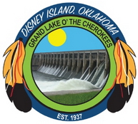
Town of Disney
322 West Main, P. O. Box 318
Disney, Oklahoma 74340
918-435-8242 (phone and fax)
www.townofdisneyok@gmail.com
-------------------------------------------------------------------------------------------------------------------------------

SPECIAL MEETING AGENDA
TOWN OF DISNEY

THE REVITALIZATION COMMITTEE FOR THE TOWN OF DISNEY WILL MEET ON MONDAY, FEBRUARY 9, 2026 @ 5:30 PM AT DISNEY TOWN HALL, LOCATED AT 322 WEST MAIN.

CALL TO ORDER
PLEDGE OF ALLEGIANCE
ROLL CALL
DECLARATION OF QUORUM

- Discussion and possible action regarding a welcome banner to promote upcoming events.
- Discussion and possible action on a town Facebook page.
- Approval of adjournment.

Posted this 6th day of February, 2026 at 1:00 p.m., in compliance with the Open Meeting Act, 25 O.S. §322, of the State of Oklahoma.

ATTEST:

____________________________

April Castens, Town Clerk

